**What’s in the stars for the Prince of Cambridge?**

By Karen Branch, special to HLN

updated 10:28 AM EDT, Thu July 25, 2013

NEED TO KNOW

* The Prince of Cambrige is a Cancer
* What does that mean for his future and personality?
* Astrologer Karen Branch weighs in

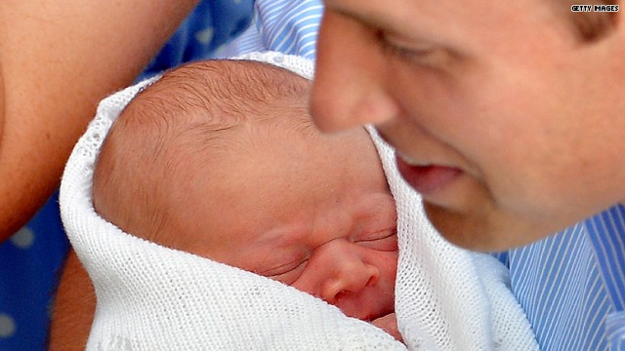



**[Hello, world! See Baby Cambridge make his debut](http://www.hlntv.com/video/2013/07/23/royal-baby-first-appearance)**

[[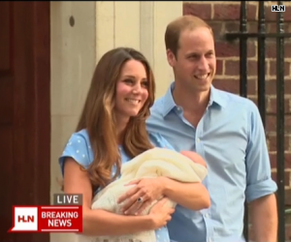](http://www.hlntv.com/video/2013/07/23/royal-baby-first-appearance)](http://www.hlntv.com/video/2013/07/23/royal-baby-first-appearance)

*Editor’s note: Karen Branch is an* [*astrologer*](http://www.newattitudesastrology.com/) *based in Atlanta. She is an active member of the Metropolitan Atlanta Astrological Society.*

The wait is over! The [royal baby arrived](http://www.hlntv.com/slideshow/2013/07/23/royal-baby-first-look-prince-charles-harry-arrive-hospital) on July 22, 2013, at 4:24 p.m. in London.

Since I am an astrologer, as soon as I heard the news, I couldn’t wait to cast his astrological chart. A birth chart is calculated using the exact date, time, and location of birth. It is basically a map of the positions of the Sun, Moon and planets at the moment he took his first breath.

So, is the prince a Cancer or a Leo? He was born with the Sun in Cancer; however, if he had been born just 30 minutes later, he would have been a Leo! The planets Mercury, Mars and Jupiter were traveling through Cancer as well, giving that sign a very big influence on his personality.

As a Cancer, he will be emotionally sensitive and have strong security needs. Home and family will always be central to him. He is lucky: His father, Prince William, Duke of Cambridge, is also a Cancer, and his mother, Duchess Catherine, has the Moon placed in that sign, giving them both natural parenting skills. They will be able to nurture him so that he will grow to be kind, compassionate and sympathetic toward others.

If he has siblings, he will want to be a part of their caretaking and will be quite protective of them.

As a future king, he will be a strong, intuitive leader, always in touch with the needs and feelings of others.

The prince was born near a Full Moon, which means the Sun and the Moon are in opposite signs. His Moon is in Capricorn, balancing his emotional nature with practicality, a keen sense of responsibility and natural leadership ability. He will be innately self-disciplined, goal-oriented and ambitious. Mother Kate has a Sun in Capricorn and will no doubt model these characteristics to her son.

The royal baby’s ascendant, or Rising Sign, is Scorpio, which symbolizes his outward personality and appearance. He may seem to be mysterious and charismatic; this rising sign is famous for intense, penetrating eyes! Since it’s another sign associated with strong emotion and passion, the prince will be very perceptive — a bit of a detective or psychologist. He will be able to pick up on subtle nuances in people and situations while being quite secretive himself.

The prince’s biggest challenge is learning how to manage all this intensity and deep emotional sensitivity. It is important that from an early age he feels safe, protected and secure. Otherwise, he may be at the mercy of fluctuating moods, making him too vulnerable and needy.

At the time of his birth, there was a rare and beautiful triangle between three planets. In astrology, this is known as a Grand Water Trine between Jupiter, Saturn and Neptune. When expressed in its highest potential, this will give the prince idealistic and visionary tendencies, with a strong urge for social justice and equality. It also creates within him the ability to act on these dreams in order to bring them into reality.

I can’t help but wonder if perhaps some of Princess Diana’s energy has been passed on to this little one so he may continue in her footsteps!